LINUX COMMANDS EXECUTION
- Identifying directory and file
File – Initially it represents ‘-‘
Directory- Initially it represents ‘d’
- r =read = 4
- w =write =2
- x = execute =1
- we have 3 times of rwx :1st rwx = owner
2nd rwx =groups
3rd rwx =others
chmod -change modifications
chmod 777 represents the full permissions
- If we have to check the users availablility in this particular machine command :
cat /etc/passwd
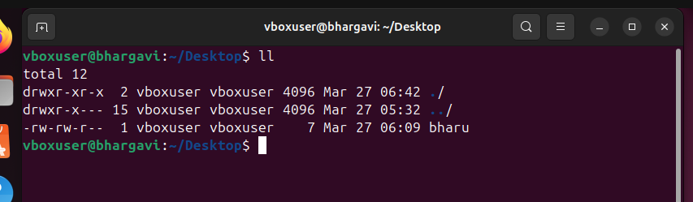

- Changing permission of a file:
chmod: this is the command used to change the permissions of directory.
- I have changed the permission of the file for owner, group and
other users.
Before the owner and group had read write ,execute and other users had
write permission.
- After change the owner has read, write and execute permission group has read,
write permission and other users have execute permission.
Command to check all the users in Linux:
cat /etc/passwd
- Creating a new user in Linux:
useradd is the command to create a new user in Linux.
- I have created a user named bharu in the above example.
Adding Password to a user:
passwd is the command to add a password to user.
passwd
username
Here I have updated the password for the user bharu
Switching from one user to another:
- su is the command to switch user
- Here I have switched from vboxuser to bharu user and the dollar represents the
sh shell.
- Root is the user with the highest privileges which means root user can do
anything on a linux machine.
As a user we will not have access to do every task like installing,creating or anything etc for that time we
need to our user to have sudo priveleges command.
Currently the user does not have sudo privileges because it is not in the
sudoer file.
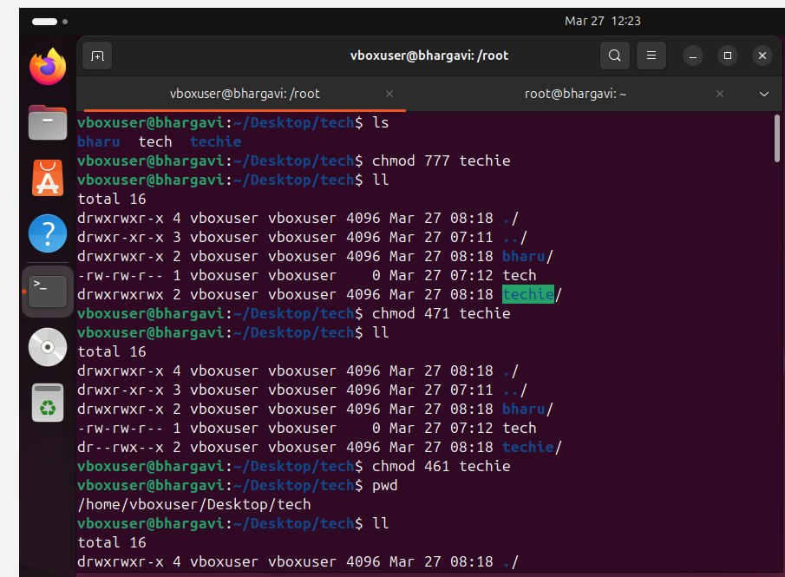
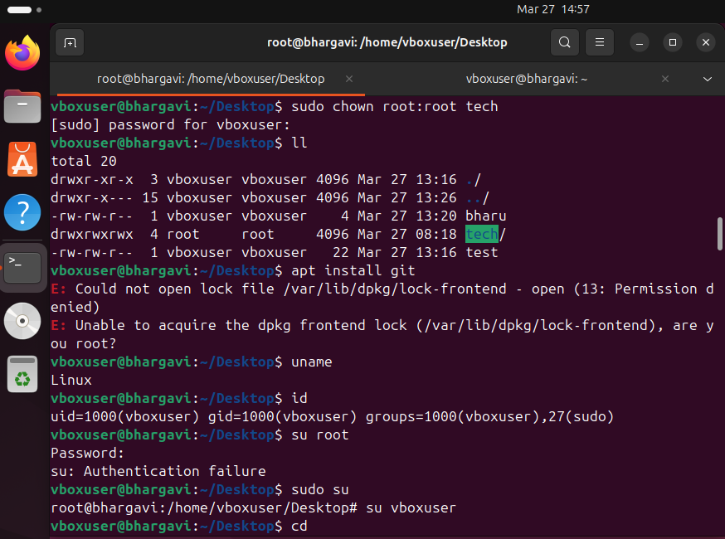
- 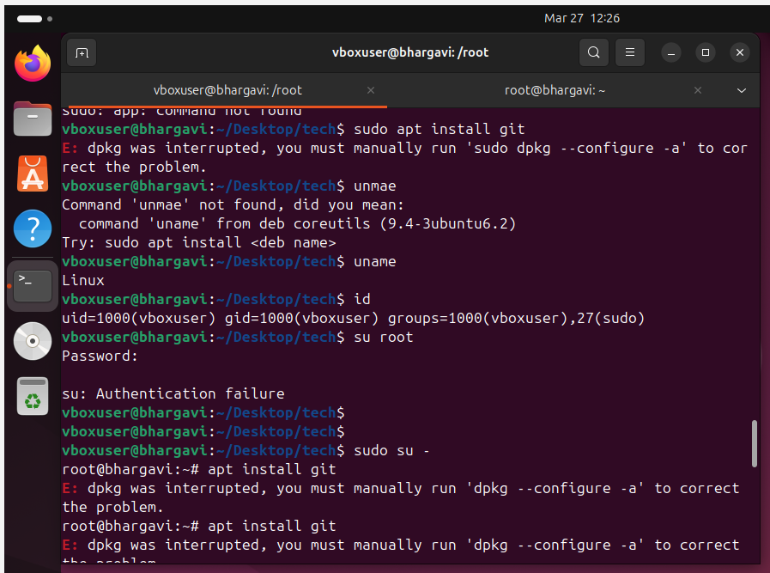
- 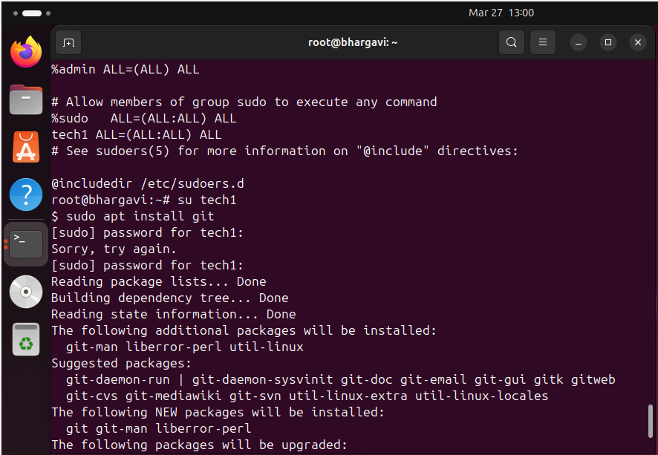
Echo – it displays the given input as a output.
• echo “ world” – it prints world
• echo “world” > test – it means we are saving as a file
• Head -3 - To read the first 3 lines of command
• Tail -3 - To read last 4 lines of command
- sudo means “super user do” 

 

